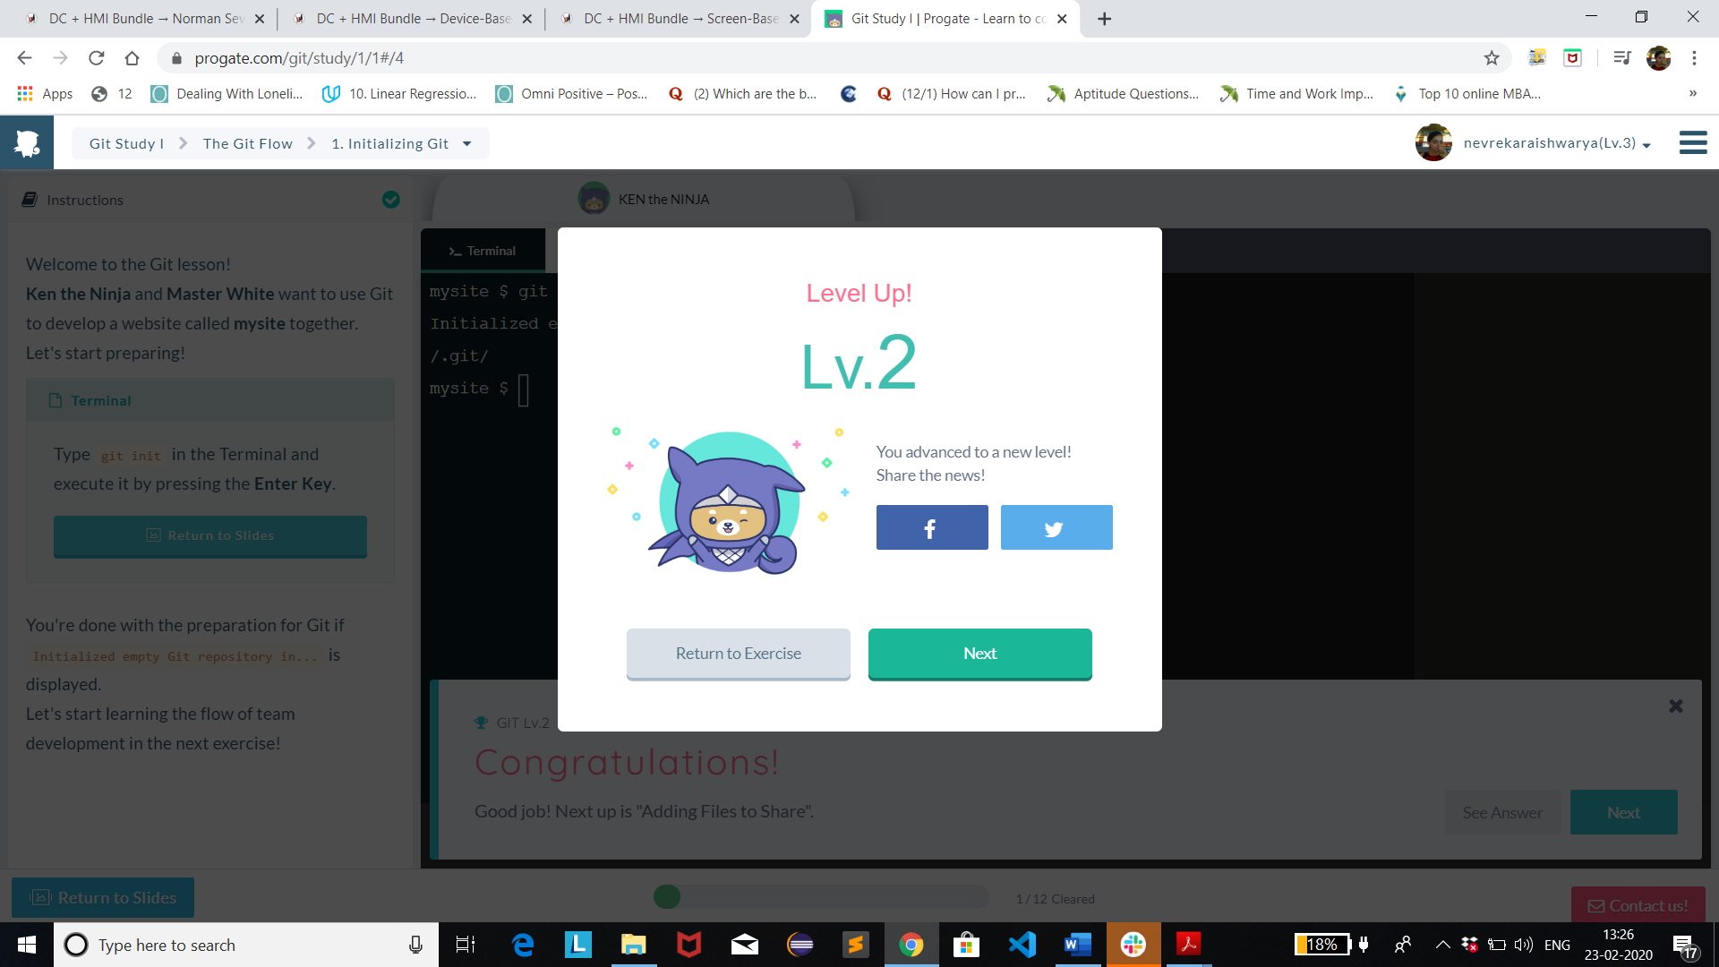

v

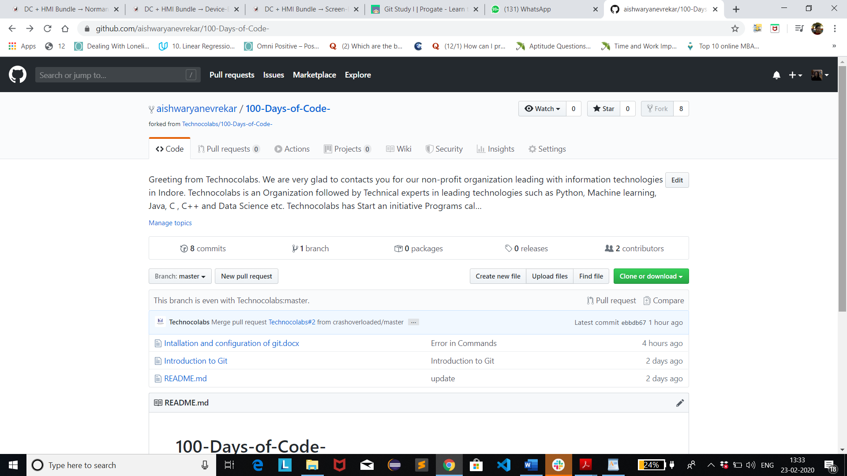

v

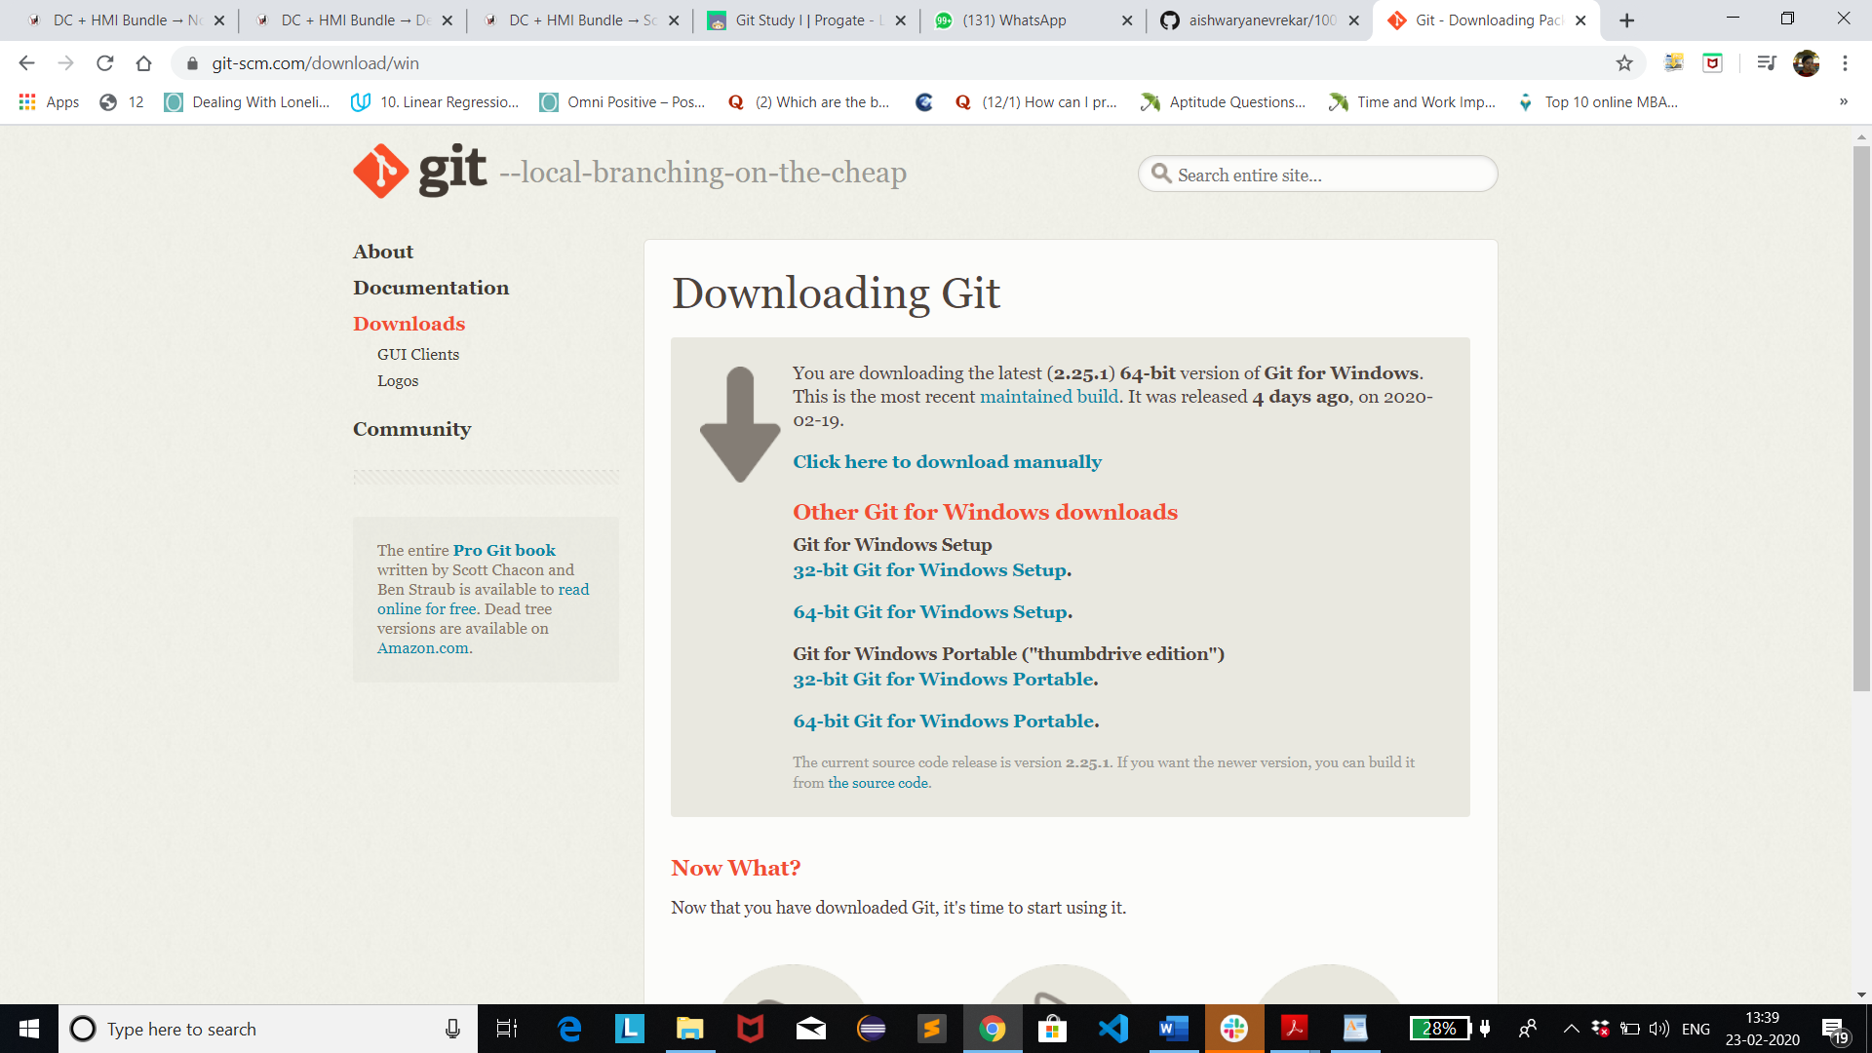

v

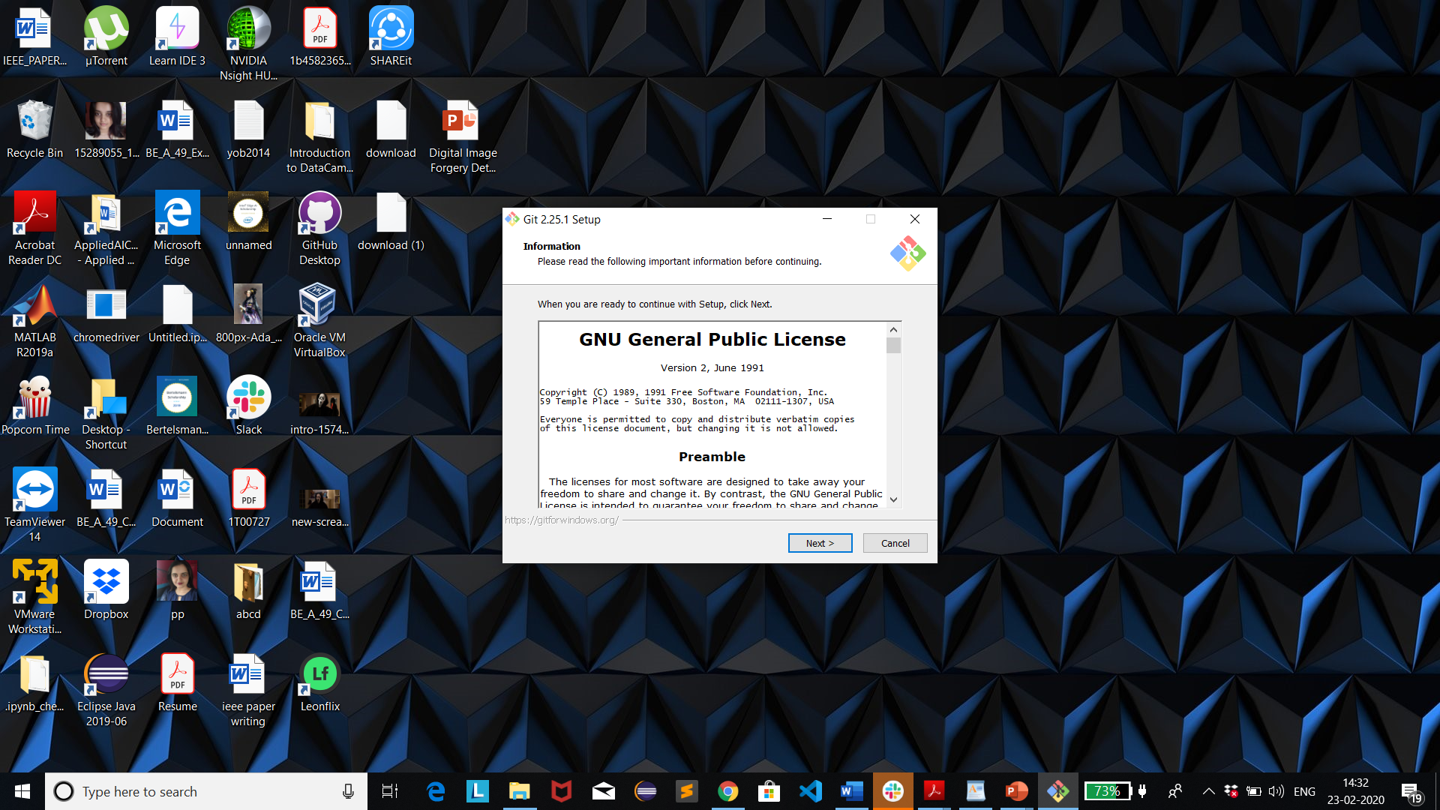

v

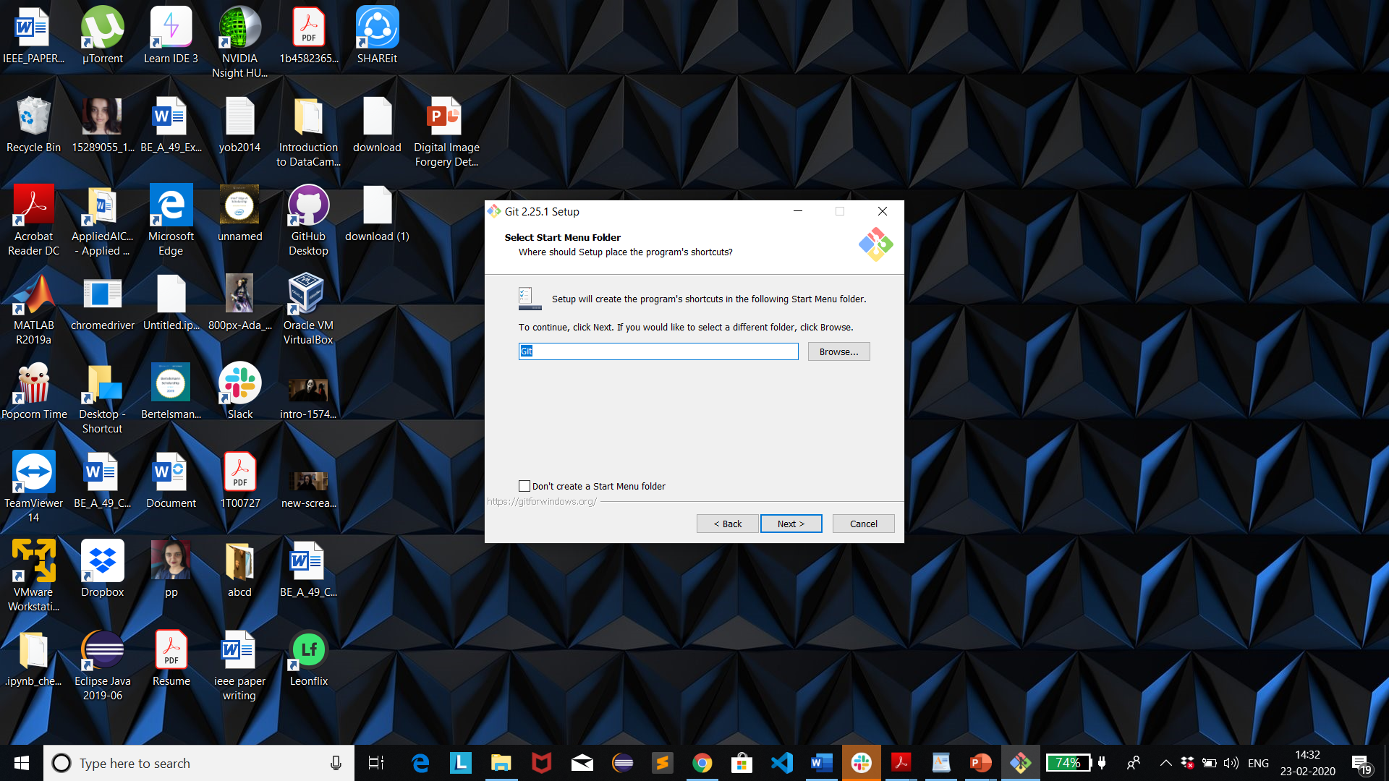

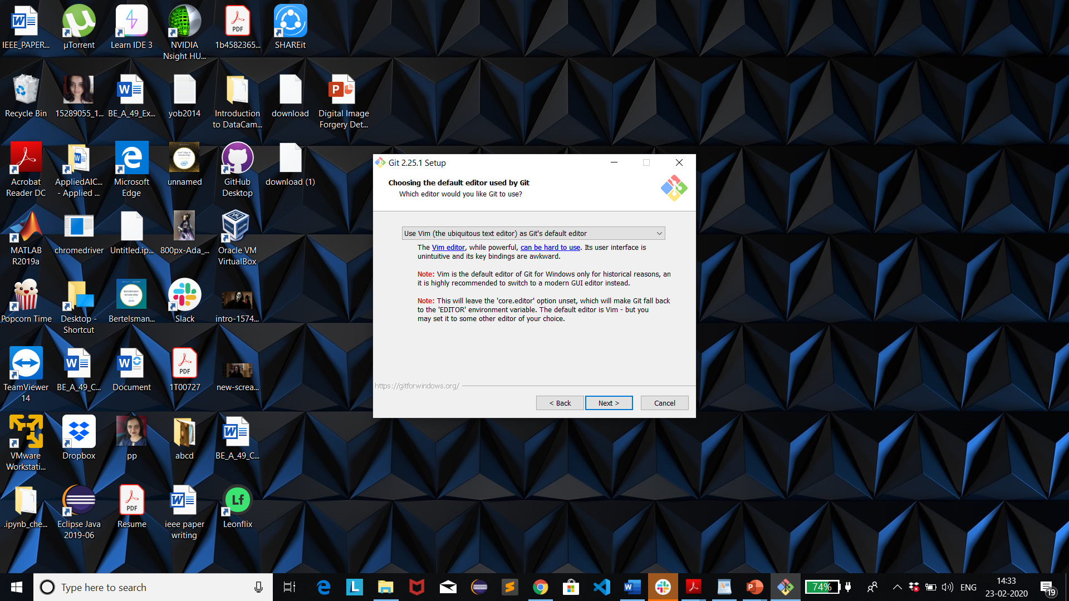

v

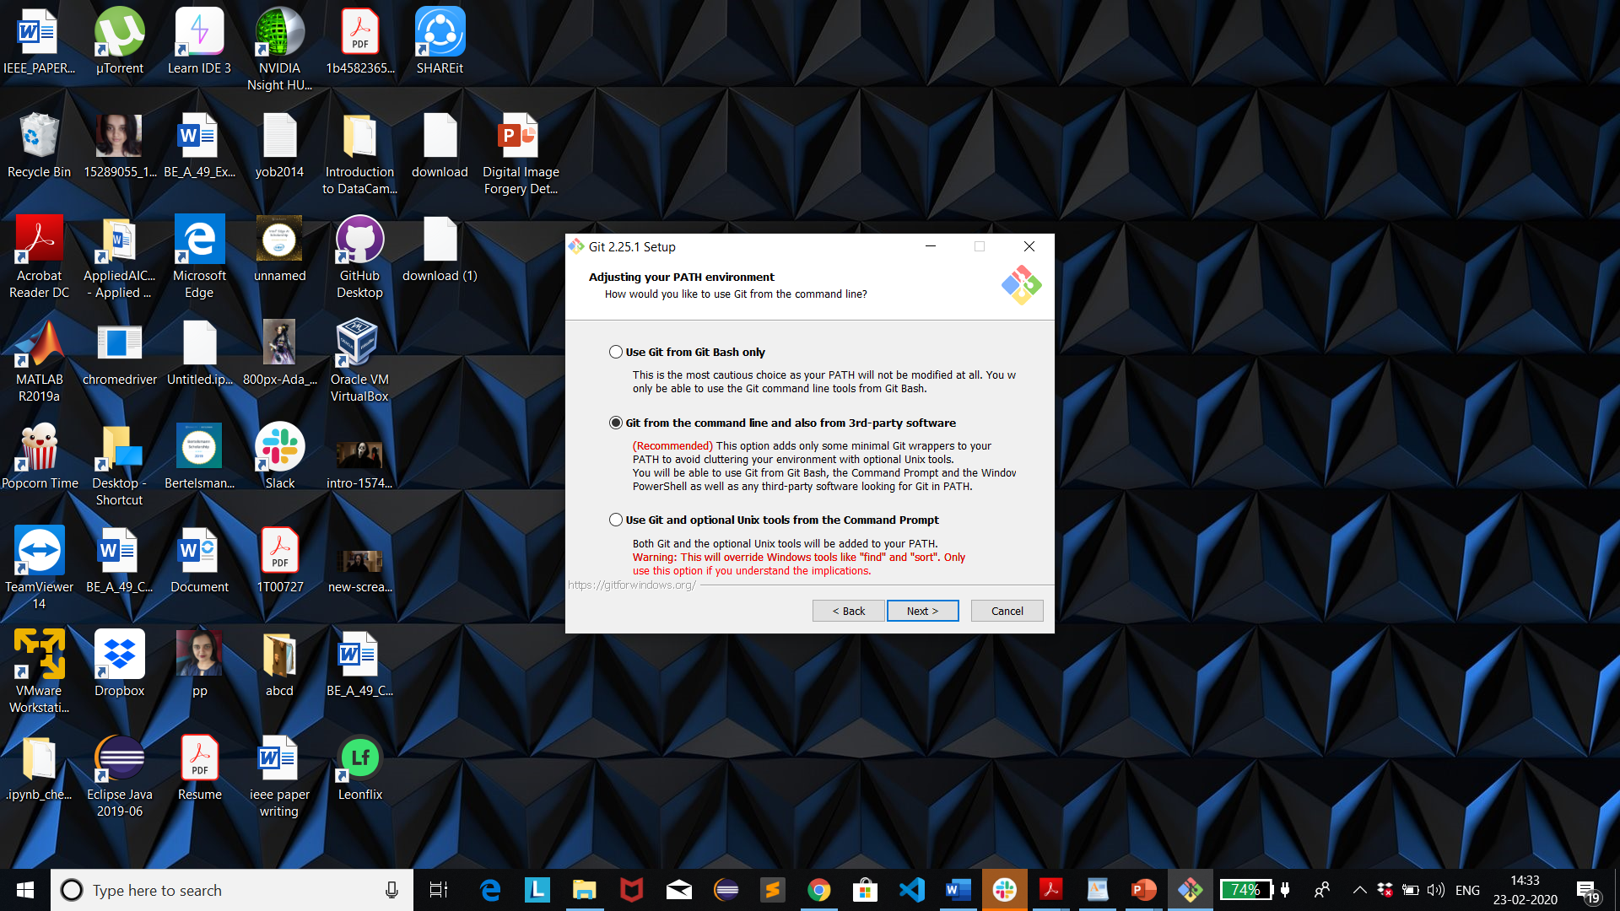

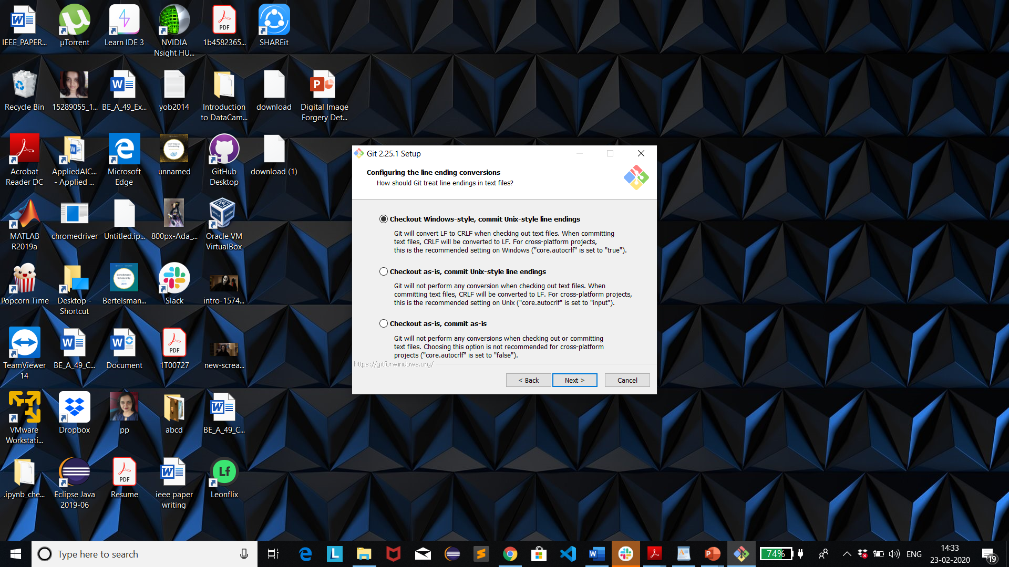

v

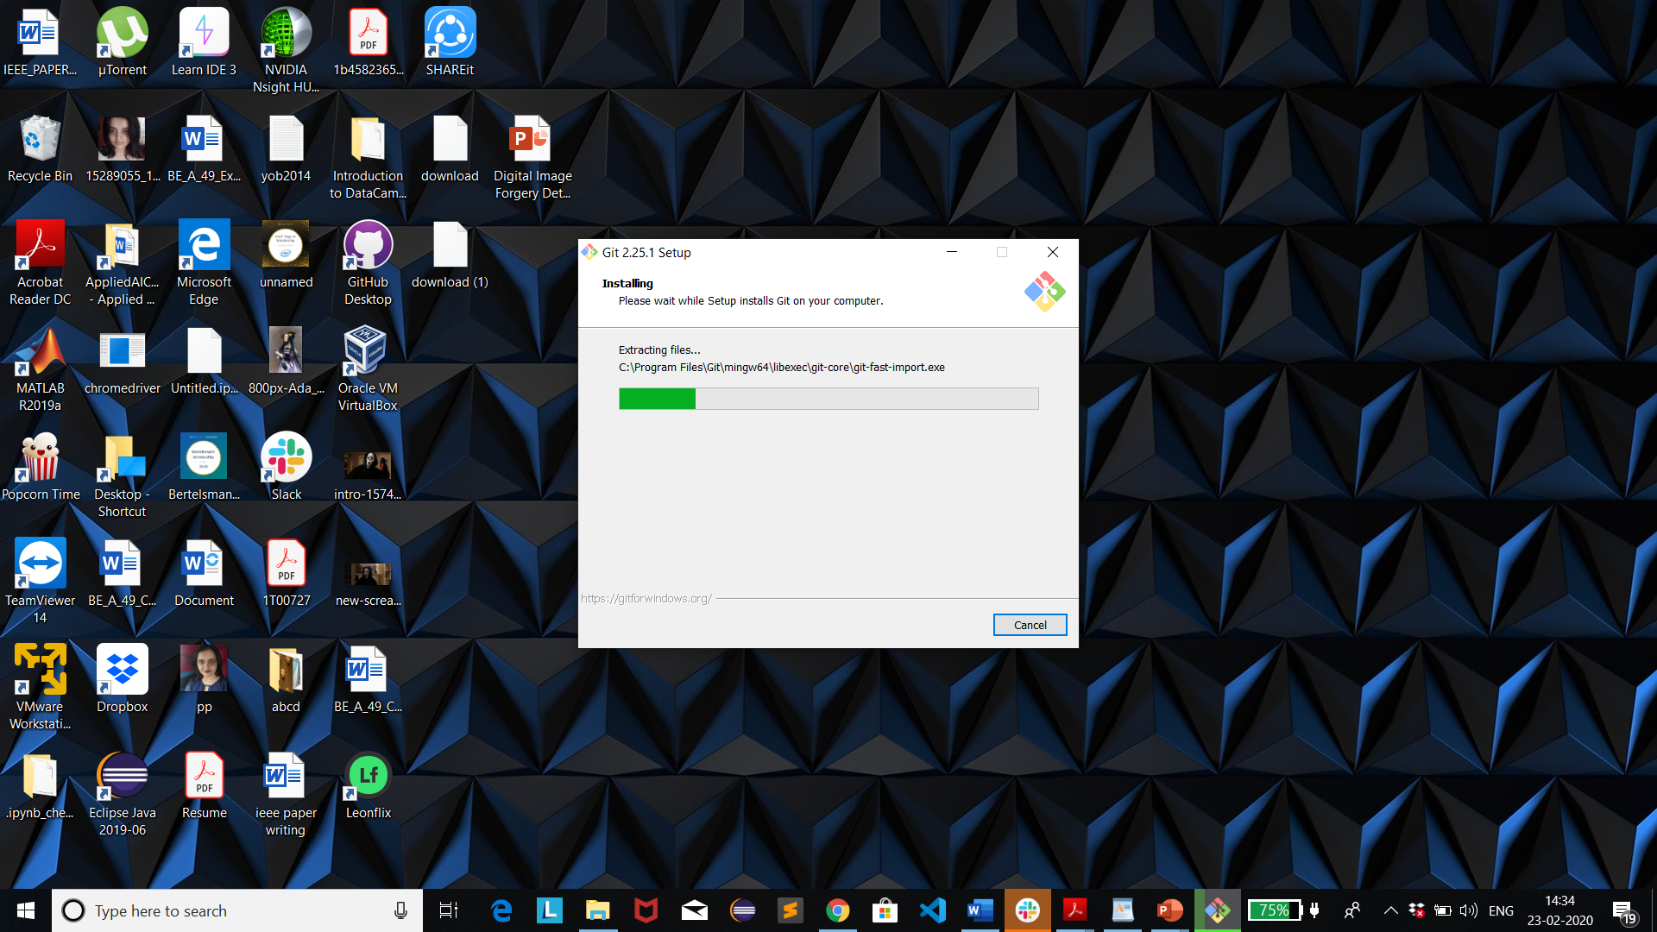

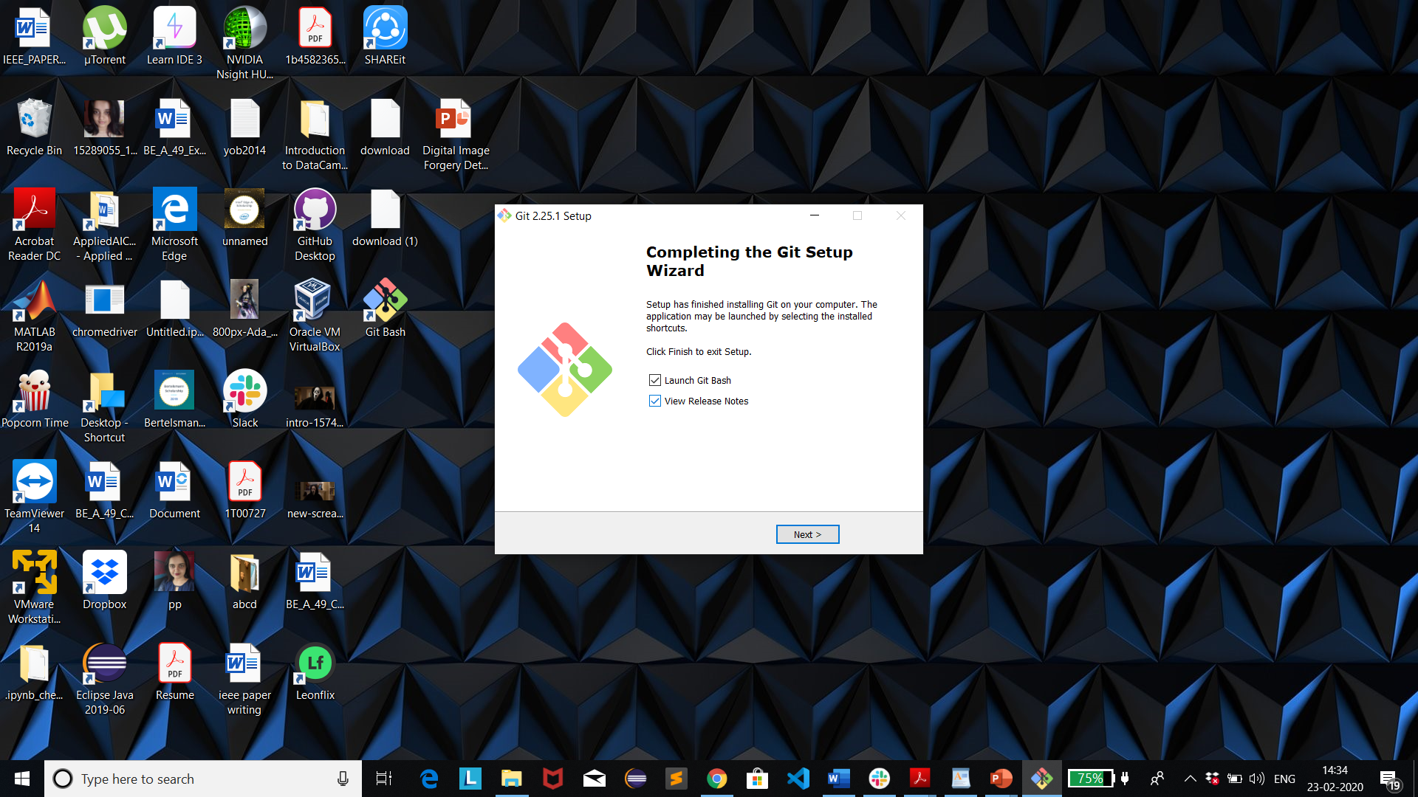

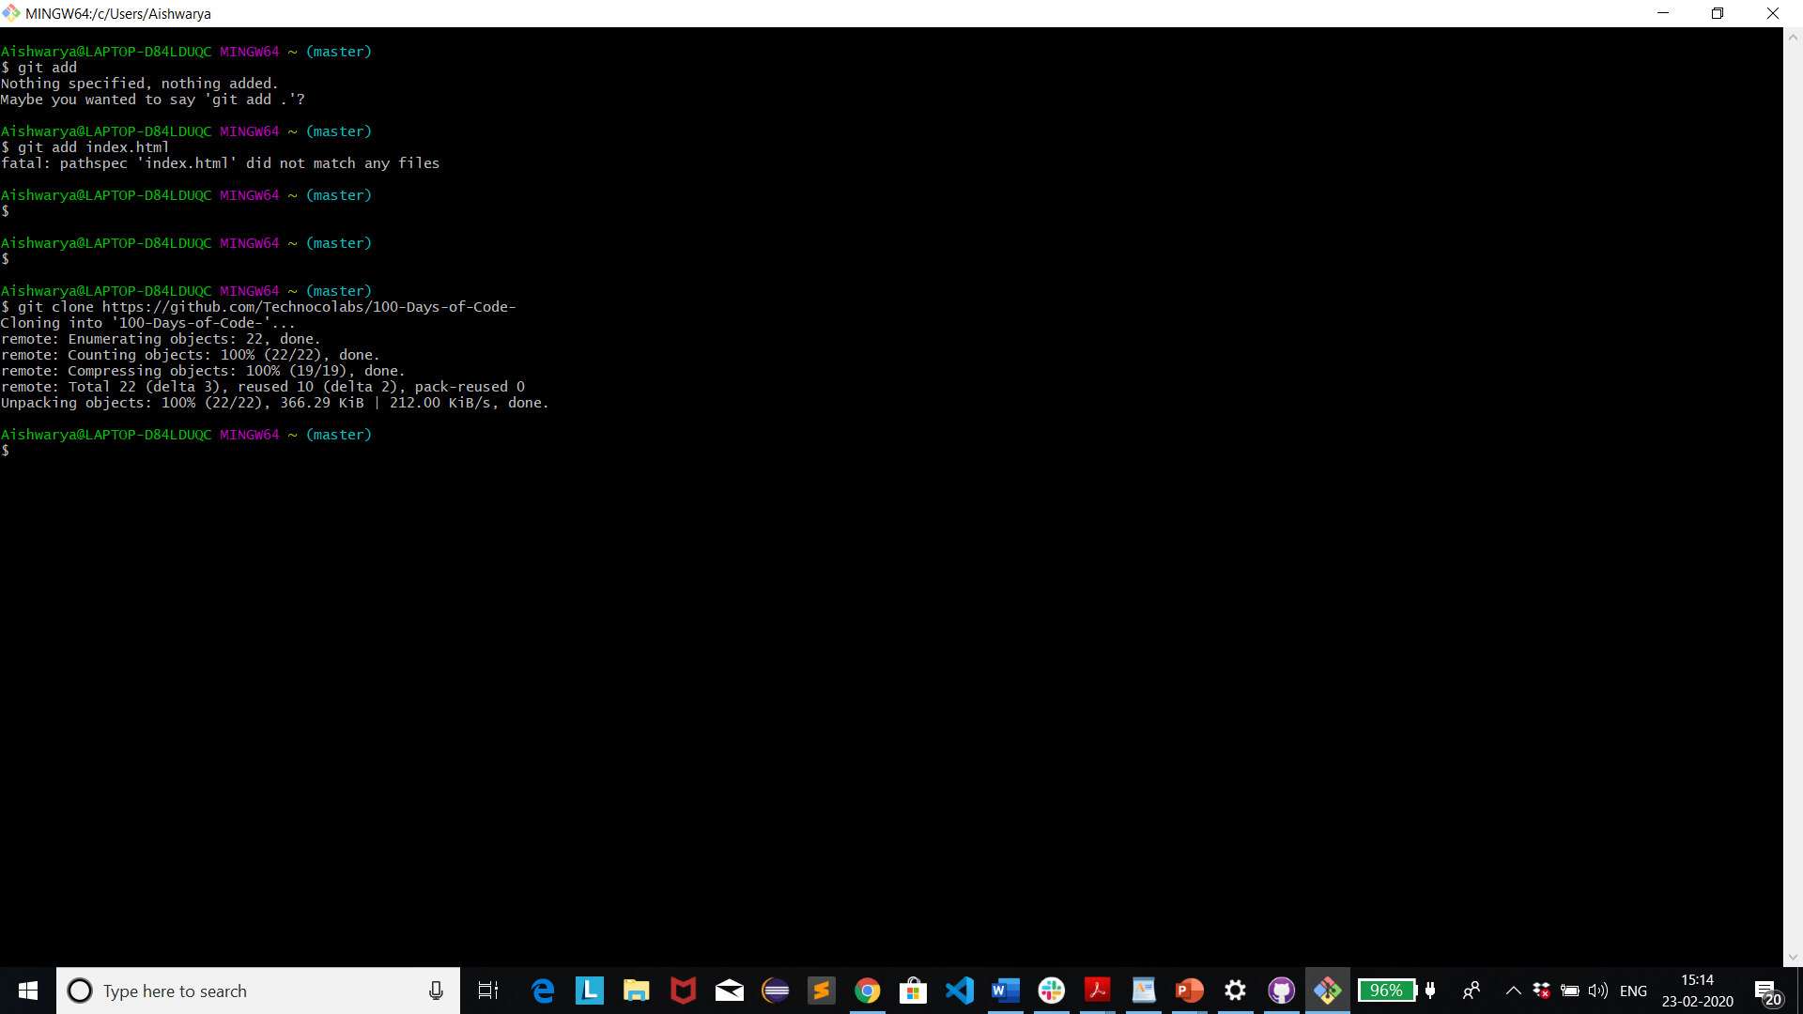

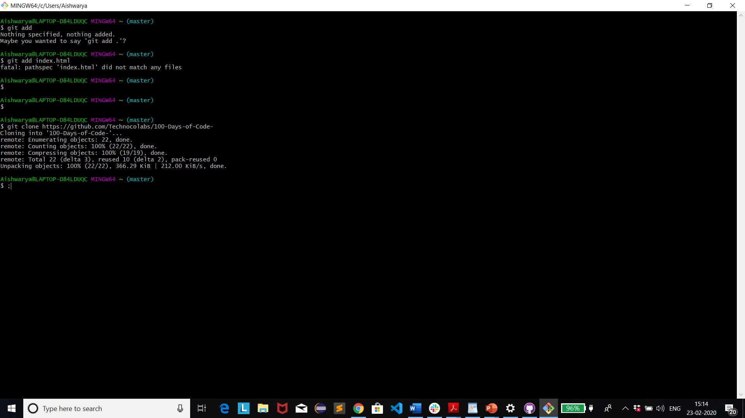

Aishwarya@LAPTOP-D84LDUQC MINGW64 ~ (master)

$ git add

Nothing specified, nothing added.

Maybe you wanted to say 'git add .'?

Aishwarya@LAPTOP-D84LDUQC MINGW64 ~ (master)

$ git add index.html

fatal: pathspec 'index.html' did not match any files

Aishwarya@LAPTOP-D84LDUQC MINGW64 ~ (master)

$

Aishwarya@LAPTOP-D84LDUQC MINGW64 ~ (master)

$

Aishwarya@LAPTOP-D84LDUQC MINGW64 ~ (master)

$ git clone <https://github.com/Technocolabs/100-Days-of-Code>-

Cloning into '100-Days-of-Code-'...

remote: Enumerating objects: 22, done.

remote: Counting objects: 100% (22/22), done.

remote: Compressing objects: 100% (19/19), done.

remote: Total 22 (delta 3), reused 10 (delta 2), pack-reused 0

Unpacking objects: 100% (22/22), 366.29 KiB | 212.00 KiB/s, done.

Aishwarya@LAPTOP-D84LDUQC MINGW64 ~ (master)

$ ;